Testing of modified rigging towards reduction of unwanted catches in the Nephrops fishery
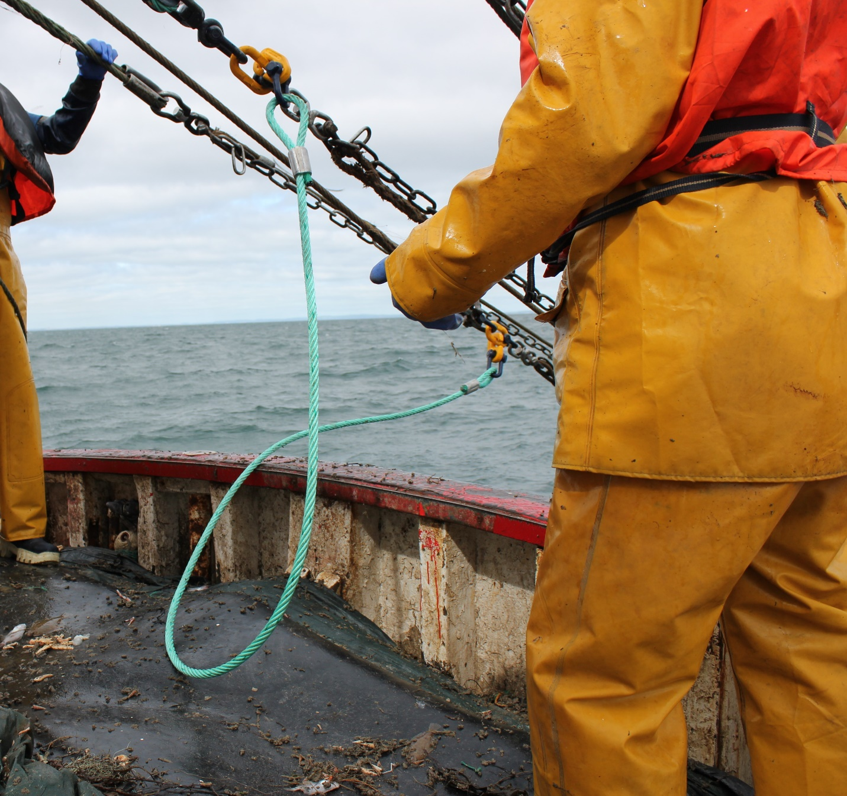
Fisheries Conservation Report August 2022
Testing of modified rigging towards reduction of unwanted catches in the Nephrops fishery
Daragh Browne¹*, Matthew McHugh¹, Shane Murphy², Cóilín Minto², Martin Oliver¹, Ronán Cosgrove¹

Key findings
- No reduction in catches of small whiting or haddock
- Observed reductions in ray species and dogfish
- Observed increases in Nephrops catches
- Further testing needed to confirm these results

- 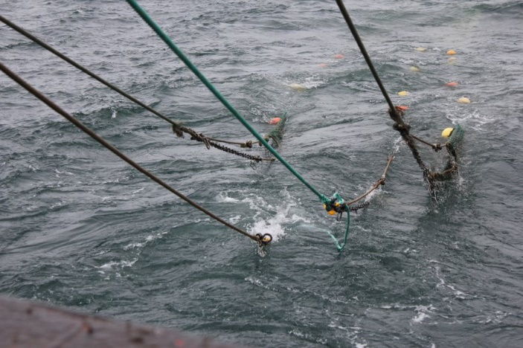

- Irish Sea Fisheries Board (BIM), New Docks, Galway, Ireland.
- Atlantic Technological University, Dublin Road, Galway, Ireland.
*Email: daragh.browne@bim.ie

Introduction
The western Irish Sea, Nephrops functional unit 15 in ICES division 7.a, is an important fishing ground for Nephrops. The TAC for whiting is restrictively low and relatively high catches of whiting below the minimum conservation reference size (MCRS) of 27 cm are taken in the Nephrops fishery. BIM and the Irish fishing industry have developed a number of gear modifications that reduce < MCRS whiting in the Irish Sea. These include the 300 mm square mesh panel (BIM, 2014) and Seltra sorting box (Tyndall et al., 2017). However, these modifications are ineffective for very small whiting < 20 cm which can form an important component of whiting catches in the Irish Sea (ICES, 2017). Once they reach the codend, these very small fish are likely to be relatively passive and incapable of leaving the trawl through large mesh escape panels.
Further trials by BIM and industry have shown how it is possible to substantially reduce catches of < 20 cm whiting by using a Swedish grid (Cosgrove et al., 2016) or 90 mm codend mesh (Browne et al., 2018a). However, both modifications result in loss of wanted catches. Also, the Swedish grid can be associated with handling difficulties (Graham and Fryer, 2006) and survival of whiting escapees through 90 mm diamond codend mesh is questionable (Sangster et al., 1996). Releasing fish before they enter the trawl is likely to result in better rates of survival (Suuronen, 2005, Melli et al., 2018). Floating Dyneema sweeps and fish scaring ropes mounted ahead of the trawl have also been tested but failed to reduce catches of very small whiting (Browne et al., 2018b).
Here we test modified rigging ahead of the trawl which aims to provide a gap between trawls through which fish herded by the trawl sweeps can escape. This work follows on from earlier testing of multiple potential gear solutions with side scan sonar (Browne et al., 2021a).

Material and methods
Fishing operations and gear
The trial was carried out in the western Irish Sea (ICES Division 7.a) in May 2022 on board the MFV Ocean Breeze 2 (D96), an 18 m Nephrops trawler. Fishing gear comprised two identical 40 m (footrope length) trawls in half quad-rig configuration and manufactured by Pepe Trawls, Howth (Table 1). A 4-panel SELTRA sorting box and codend with 300 mm square mesh in the top sheet was fitted to both the 2-panel trawls using an adaptor section (Tyndall et al., 2017) in line with technical measures regulations in the area.
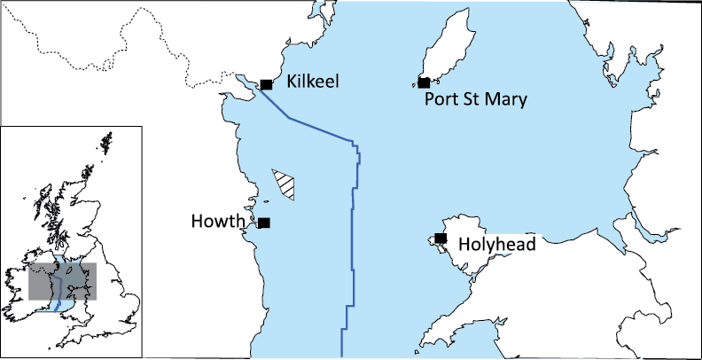
Figure 1. Trial location in the western Irish Sea, ICES division 7.a
The control gear comprised sweeps rigged in half quad-rig configuration (Figure 2a). The test gear comprised a modified half quad-rig sweep configuration where two middle sweeps were joined fore and aft by horizontal ropes (Figure 2b). The test gear was further modified half-way through the trial, for hauls 9 to 16, where three 203 mm (8-inch) rubber ground gear discs were attached to the centre and each end of the horizontal ropes. This modification aimed to raise the horizontal ropes off the bottom as small Gadoids have been observed to escape under the ground gear of trawls (Walsh, 1992).

Table 1. Vessel, trawl and sweep specification
Engine power (kW) | 224
Warp diameter (mm) | 16
Door manufacturer/ model | Bison 7plus
Door weight (kg) | 250
Trawl manufacturer | Pepe Trawls
Headline length (m) | 36
Footrope length (m) | 40
Fishing circle (meshes x mm) | 380 x 80
Sweep/ horizontal rope material | Combination wire rope (22 mm diameter)
Sweep configuration | Control | Test
Outer sweep length (m) x number | 70 x 2 | 70 x 2
Split/ vee sweep length x number | 50 x 2 | 50 x 2
Middle sweep length (m) x number | 20 x 1 | 20 x 2
Horizontal rope length (m) x number | n/a | 3.6 x 2

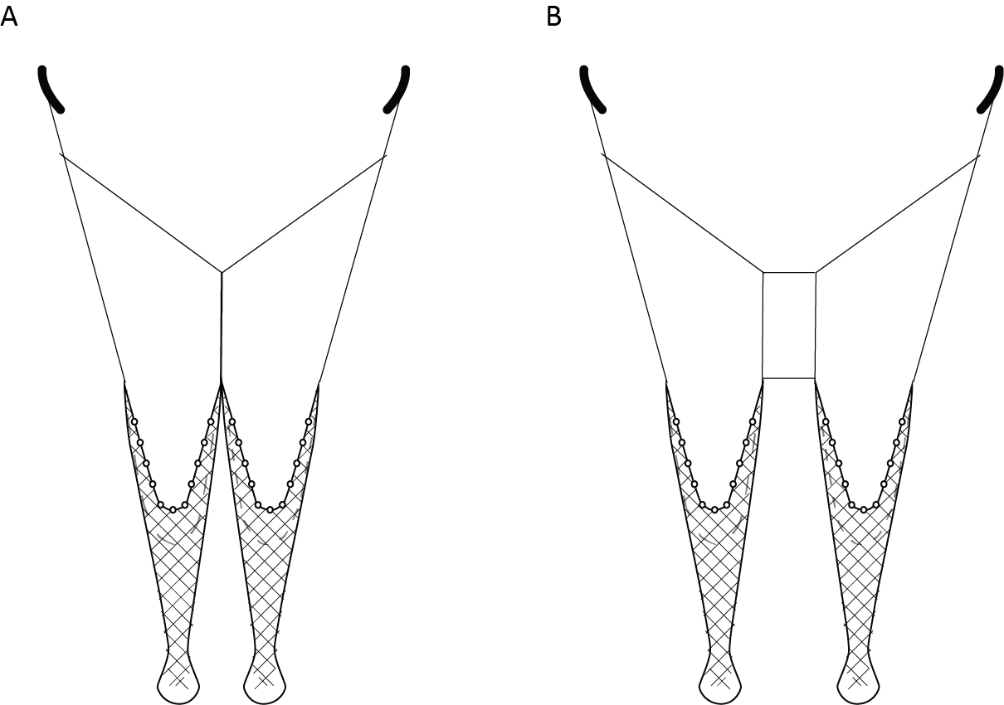Figure 2. Standard half quad-rig sweep configuration (A) modified half quad-rig sweep configuration (B).

Sampling and analysis
Given the nature of the gear modification the trial was designed as a catch comparison using the alternate haul method (Wileman et al., 1996). To minimise between-haul variability, test and control gears were deployed consecutively and to facilitate matching in subsequent analysis, each pair of hauls was conducted on the same ground (Browne et al., 2021b). To maximise the number of deployments haul duration was reduced to 2 hours.
Total catches from each haul were separated to species level. All quota fish species were weighed and where required subsamples were randomly selected and weighed. Total length (TL) of commercial fish species were measured to the nearest cm below. Carapace length (CL) of Nephrops were measured using digital vernier callipers wirelessly linked to a PC. Non-quota fish species such as lesser spotted dogfish were sorted and weighed but not measured. Other non-quota species such as gurnards and poor cod were grouped together, weighed and recorded as “non-quota fish discards”. Relatively small quantities of black sole, lemon sole, witch, megrim, brill and turbot were caught in the trial and species weights are here grouped and presented as “flatfish”. Spotted, thornback and blonde ray were also caught in relatively small quantities and are here grouped as “rays”.
Proportional differences in catches of key species were modeled using generalised linear mixed models (GLMM) and the glmmTMB package in R (Brooks et al., 2017).

Results
A total of 16 hauls were completed over 4 days during May 2022. Mean haul duration, towing speed and depth fished during the trial were: 2 hrs, 2.7 kt and 31.8 m. Weather conditions were fair during the trial with wind direction backing from NW to S and wind speeds decreasing from 28 to < 0 km/h.
The main commercial species caught were Nephrops, whiting, plaice and haddock. Observed catches of whiting, haddock and Nephrops were greater in the test gear (Table 2).
Table 2. Overall catch weights(kg) in control and test gears and percentage difference
Species | Control | Test | Difference (%)
Nephrops | 633 | 818 | 29
Whiting | 63 | 74 | 17
Haddock | 69 | 95 | 38
Cod | 1 | 0.5 | -50
Plaice | 136 | 126 | -7
Flatfish | 44 | 42 | -5
Monkfish | 8 | 5 | -38
Lesser spotted dogfish | 343 | 246 | -28
Rays | 25 | 16 | -36
Non quota fish discards | 446 | 497 | 11
Non fish discards | 125 | 120 | -4
Total catch | 1893 | 2040 | 8

The majority of Nephrops caught in both gears were > MCRS while most plaice, haddock and whiting were < MCRS (Figure 3). The SELTRA sorting box is likely to have substantially reduced catches of larger whiting and haddock (Tyndall et al., 2017).
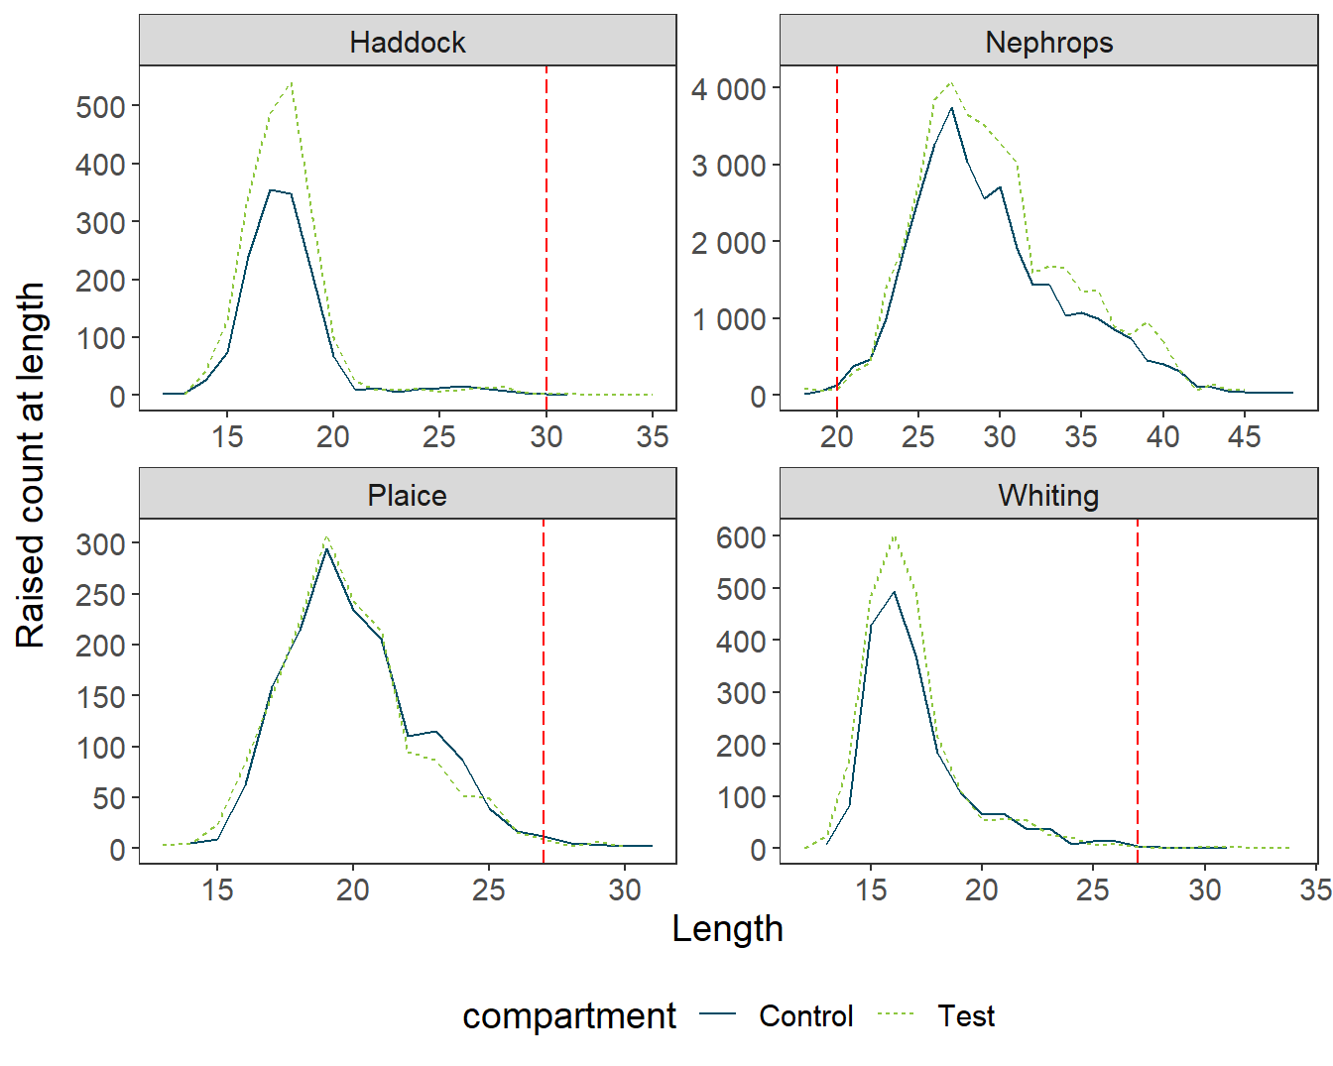
Figure 3. Overall length-frequency plots for key species. The green hatched line represents the test gear and navy solid line the control gear. Vertical hatched lines denote MCRS for each species. Length is measured in cm for fish (TL) and mm for Nephrops (CL).

Catch curves showed no significant difference in catch at length for key species (Fig. 4). Confidence intervals (95%) were generally large likely due to elevated levels of variability between and within matched pairs of hauls. In one pair of matched hauls (hauls 1 and 2) almost all the whiting caught were in the test gear which had a disproportionate effect on the overall mean curve and biased the model fit. Removal of the random effects from the model improved the curve’s fit but resulted in unrealistically narrow confidence intervals. We therefore removed the confidence intervals for whiting but note that, from the random effects fit, that they would likely span 0.5 throughout.
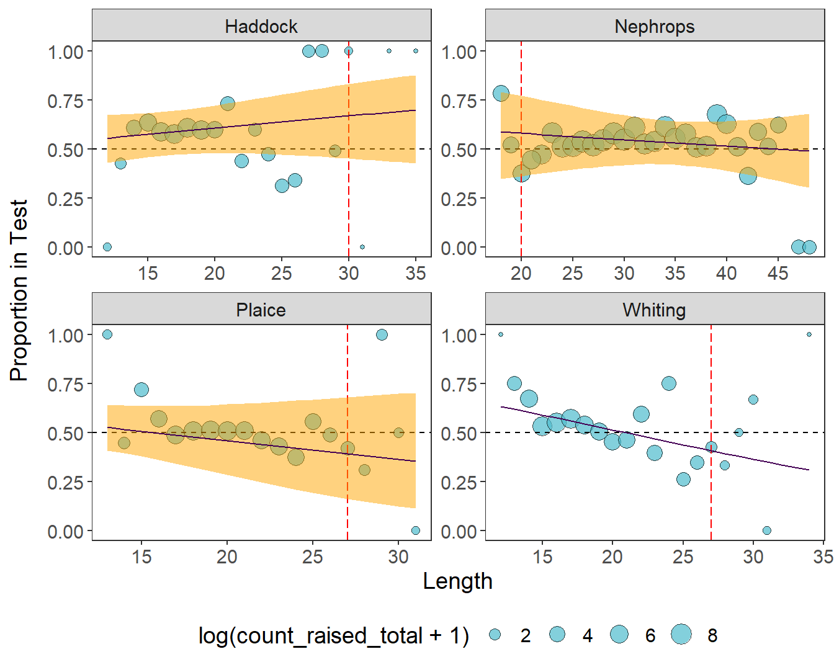
Figure 4. Overall proportions retained at length in the test gear. Diameter of each point is proportional to the log of the raised count at length. Overall mean GLMM curve (solid line) with 95 % confidence intervals (orange band). Vertical hatched lines denote MCRS for each species. Length is measured in cm for fish (TL) and mm for Nephrops (CL).

Discussion
The test gear did not reduce catches of whiting below 20 cm. In fact, greater catches of whiting and haddock < 20 cm and Nephrops across most size classes were observed in the test gear (Figure 3). These differences were not significant likely due to relatively high between-haul variability. This was particularly evident on day 1 (hauls 1-4) when the tides were stronger than expected and on day 4 (hauls 13-16) when extensive algal fouling of the gear was present. These fluctuating environmental variables are likely to have affected gear performance and trial results.
Shortened haul durations of two hours were chosen to maximise the number of hauls during the trial. The tidal slacks at high and low water are considered to be the optimal time for Nephrops burrow emergence so shortened haul durations of 2 hours may be subject to more variability than normal commercial hauls of 4 hours or longer. This issue should be considered in designing future alternate-haul gear trials.
Observed increases in catches for some species suggests potential improvements in catching efficiency in the test gear. The addition of horizontal ropes yielded more door spread in the test gear but the increase was generally equivalent to the length of the horizontal sweeps. An increase in wingend spread has been shown to increase catches but previous side-scan sonar observations suggest wingend spreads were not increased in the test gear (Browne et al., 2021a). The addition in the test gear of the second centre sweep along with the horizontal ropes could allow improved bottom contact for each of the twin trawls which could explain increased Nephrops catches. The skipper of the trial vessel has continued using the modified rigging post-trial due to increased Nephrops catches which bodes well for the performance of the gear in this regard.
Failure of small whiting and haddock to pass through the escape gap between trawls may be due to their swimming speed which is known to be size dependent (Breen et al., 2004; Melli et al., 2018). The herding effect may not apply to small fish due to their inability to respond to encroaching sweeps.
Observed catches of larger fish such as dogfish, rays and flatfish were reduced in the test gear suggesting that the modified rigging may have potential for reducing unwanted catches of these species. Further testing and verification are needed but these results are encouraging given requirements to reduce catches of some biologically sensitive skate and ray species (Oliver et al., 2021) and all other unwanted catches to reduce fisheries impacts on biodiversity.
The addition of discs to the horizontal ropes in hauls 9-16 resulted in a slight decrease in observed catches of whiting and haddock but also in the target species Nephrops. Again, the extent to which these results are attributable to gear effects is not possible to discern due to between haul variability and the small number of hauls completed with each gear.

Acknowledgements
BIM would like to thank Ciaran Powell and the crew of the MFV Ocean Breeze 2 for a successful collaboration. This work was funded by the Irish Government and part-financed by the European Union through the EMFAF Operational Programme 2021 – 2027 under the BIM Sustainable Fisheries Scheme.

References
BIM. 2014. Assessment of a 300 mm square-mesh panel in the Irish Sea Nephrops fishery. Irish Sea Fisheries Board (BIM), Fisheries Conservation Report. 5 pp.
Breen, M., Dyson, J., O'Neill, F.G., Jones, E. and Haigh, M., 2004. Swimming endurance of haddock (Melanogrammus aeglefinus L.) at prolonged and sustained swimming speeds, and its role in their capture by towed fishing gears. ICES Journal of Marine Science, 61(7), 1071-1079.
Brooks, M.E., Kristensen, K., van Benthem, K.J., Magnusson, A., Berg, C.W., Nielsen, A., Skaug, H.J., Maechler, M. and Bolker, B.M. 2017. glmmTMB Balances Speed and Flexibility Among Packages for Zero-inflated Generalized Linear Mixed Modeling. The R Journal, 9(2), 378-400. https://CRAN.R-project.org/package=glmmTMB

Browne, D., Oliver, M., McHugh, M., Minto., C., and Cosgrove, R. 2018a. Assessment of a SELTRA sorting box with 90 mm codend mesh size in the Irish Sea Nephrops fishery. Irish Sea Fisheries Board (BIM), Fisheries Conservation Report, October 2018. 12 pp.
Browne, D., Oliver, M., McHugh, M., and Cosgrove, R. 2018b. Assessment of Dyneema floating sweeps and fish scaring ropes in the Irish Sea Nephrops fishery. Irish Sea Fisheries Board (BIM), Fisheries Conservation Report, February 2018. 10 pp
Browne, D., Minto, C., McHugh, M., Murphy, S., Oliver, M. and Cosgrove, R., 2021a. Match of the day: optimized experimental design in alternate-haul gear trials. ICES Journal of Marine Science, 78(6), 1988-1998.
Browne, D., Chopin, N., McHugh, M., Oliver, M. and Cosgrove, R., 2021b. Fast-Tracking Gear Development with Side-Scan Sonar. Irish Sea Fisheries Board (BIM), Fisheries Conservation Report, August 2021. 10 pp.
Cosgrove, R., Browne, D., and McDonald, D. 2016. Assessment of rigid sorting grids in an Irish quad-rig trawl fishery for Nephrops. Irish Sea Fisheries Board (BIM), Fisheries Conservation Report, February 2016. 9 pp.
Graham, N., and Fryer, R. 2006. Separation of fish from Nephrops norvegicus into a two-tier cod-end using a selection grid. Fisheries Research, 82, 111-118.
ICES. 2017. Report of the Second Workshop on the Impact of Ecosystem and Environmental Drivers on Irish Sea Fisheries Management (WKIrish2), 26–29 September 2016, Belfast, Northern Ireland. ICES CM 2016/BSG:02. 199 pp.
Melli, V., Karlsen, J.D., Feekings, J.P., Herrmann, B. and Krag, L.A., 2018. FLEXSELECT: counter-herding device to reduce bycatch in crustacean trawl fisheries. Canadian Journal of Fisheries and Aquatic Sciences, 75(6), 850-860.
Oliver, M., McHugh, M., Murphy, S., Minto, C., Browne, D. and Cosgrove, R., 2021. An assessment of cuckoo ray (Leucoraja naevus) survivability in an Irish otter trawl fishery. Irish Sea Fisheries Board (BIM), Fisheries Conservation Report, November 2021. 18 pp.
Sangster, G.I., Lehmann, K. and Breen, M., 1996. Commercial fishing experiments to assess the survival of haddock and whiting after escape from four sizes of diamond mesh cod-ends. Fisheries Research, 25(3-4), 323-345.
Suuronen, P. 2005. Mortality of fish escaping trawl gears, Food & Agriculture Org. 73 pp.
Tyndall, P., Oliver, M., Browne, D., McHugh, M., Minto, C., and Cosgrove, R., 2017. The SELTRA sorting box: A highly selective gear for fish in the Irish Nephrops fishery. Irish Sea Fisheries Board (BIM), Fisheries Conservation Report, February 2017. 12 pp.
Walsh, S. J. 1992. Size-dependent selection at the footgear of a groundfish survey trawl. North American Journal of Fisheries Management, 12, 625-633.
Wileman, D.A., Ferro, R.S.T., Fonteyne, R., and Millar, R.B. 1996. Manual of methods of measuring the selectivity of towed fishing gears. ICES Cooperative Research Report No. 215. ICES, Copenhagen, Denmark.

