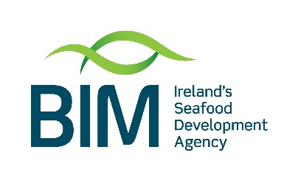
Application for Brexit Sustainable Aquaculture Growth Scheme

BUSINESS PLAN

This part of the application is used to summarise the applicant’s business plan and to give the context for the proposed project.
Registered Company Name

Trading Name if different

Company Registration Number

Year of incorporation

How long has the company been generating sales before the date of this application?
Principal Business of the company

1. Company Profile & PROJECT OVERVIEW

1.1. Company Overview
Briefly outline company history and summarise your current product/service and key markets. You might include the following headings in this profile
New Aquaculture Farmers- detail here the feasibility and any environmental impact assessments carried out.

Introduction:
E.G. This study aims to determine the feasibility of establishing a commercially viable (species) aquaculture business in (location).

(Species) Aquaculture:

Farming Method:
- Sea Based/Land based (Description of techniques to be employed. If these techniques are established/new/innovative)
- Feed
- Production Cycle (Description/length)
- Advantages of using this farming method

Proposed Sites:
- Location and description of
- Current capacity and proposed capacity
- Operation of the site

Regulatory Requirements:
- Licensing requirements
- Environmental Assessment

1.2. PROJECT OVERVIEW
This summary of the proposed project should cover the business reasons for taking on the project and the link to the company’s strategy as outlined in Section 1.1. (MAX 20 LINES)

2. Business Strategy

2.1. Key Strategic plan
Briefly define the business strategy of the company over the next 3 years? [MAX 15 LINES]

2.2. Sales and Marketing
Briefly describe your Sales and Marketing model using the following prompts [MAX 30 LINES]
- What are your key markets? What is your route to market?
- Are there any threats to your current market?
- Insert the top 3 markets (either domestic or export) that you consider are your priority markets each year and indicate what % of your total sales will be to these markets.
- New Farmers- detail here the independent marketing reports used to demonstrate that a market exists for your product.

 | This Year |  | Next Year |  | 2 years from now
Priority | Market Name* | % Total Sales | Market Name* | % Total Sales | Market Name* | % Total Sales
1.
2.
3.
 | Other |  | Other |  | Other
TOTAL |  | 100% |  | 100% |  | 100%
*The market name could be “Domestic Market” or the name of a country to which you are exporting

Management
Briefly describe the Company Management using the following prompts [MAX 15 LINES]
- Outline the current management structure.
- What are the key skills and track record of the management team and advisers?
- Do you need to create new management role(s) within the senior team to enable delivery of your strategy?

2.4 Issues/Risks
What are the key issues / risks the business faces and what actions are you taking or proposing to take to address these issues / risks?
Key Issues / Risks for the business | Proposed Actions (including those not addressed in this plan)

3. Finance

3.1. Historic and Projected Financials *

Items / Period | 2019 | 2020 | 2021 | 2022 | 2023
Sales (€000’s)
Cost of Goods Sold (e.g. seed)
Gross Profit (€000’s)
Wages
Other Expenses
Net Profit (€000’s)
Total Employment
(# Full Time Equivalents)
*These can be provided for the calendar year or the applicant’s financial year, where that is not the calendar year

