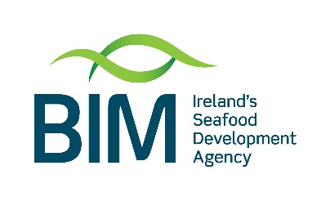
Brexit Adjustment Reserve Capital Processing Scheme
Document Name | D-001 Market Alignment
Document Max Wordcount | Up to 1,000 words of text  Data that supports this text can be uploaded separately with no word limit
Document Content | This document should describe how the proposed investment meets the identified market need. Suggested questions are provided in the Guidance Document.

Company Name
Project Name

This is focussed on your proposed investment and is specifically in reference to the application being assessed
- Please describe the market opportunity? (e.g. new markets; new customers; new products; Include here detail on the customer need for these products)

- Please describe the target market? (E.g. foodservice channel, retail channel, b2b, online etc with potential market size, growth trajectory, positioning . This should include key target geographies and their respective sizes),

- Can you describe what research you have undertaken to validate the market/customer need? E.g. include any work you have completed with Bord Bia/Enterprise Ireland or another agency in identifying this need and if so, what have you learnt from this. Include any research on/with customers

- What are the key trends for this customer/in this market to support the need identified? Describe the insight

- What problems or market needs does your proposed product or service address?

- Who are your main competitors for your proposed product or service and how will your differentiate your products to ensure success?

